STAT S 670 – Exploratory Data Analysis – Homework #3

Ganesh Nagarajan

[gnagaraj@indian.edu](mailto:gnagaraj@indian.edu)

Solutions

1. a) Level VS Spread plot without any transformation

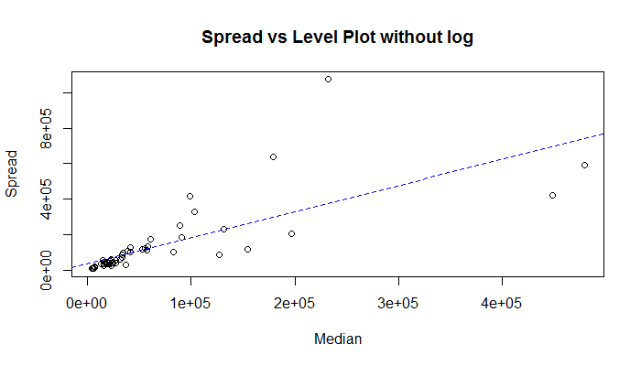

Level Vs Spread Plot with log transformation

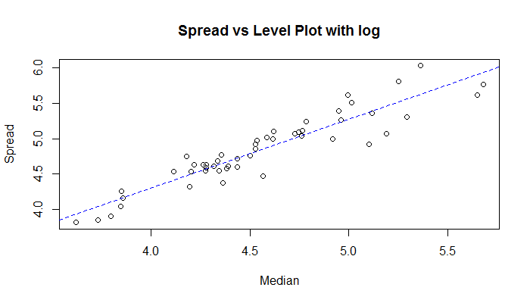

b) From the R code, 1-slope is 0.02806874

Hence from p formula, the most appropriate transformation would be log transformation.

c) Box plot without log transformation,

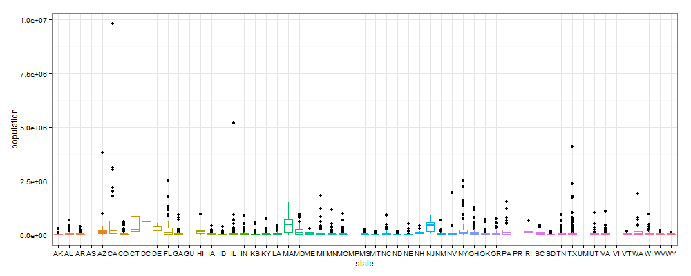

It can be seen that there are lot of outliers and outliers distort the interpretation of the box plot.

Hence as suggested by the 1-p rule, following is the box plot with log transformation applied.

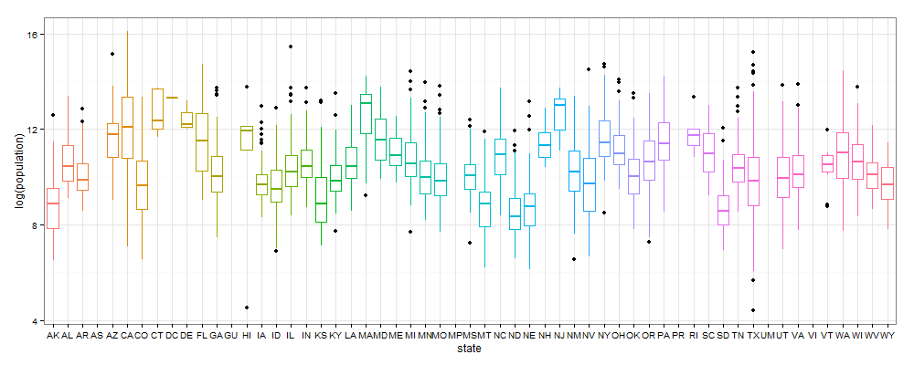

A clear visual comparison from the box plot with and without transformation supports the effectiveness of the transformation. It can be clearly seen that the box plot with log transformation has lesser outlier effects and better interpretable.

d) Transformation for symmetry table:

Since the transformation of California subset comes under transformation of data from multiple batches, this becomes a problem for transformation of symmetry.

Also, since the transformation is for a single batch, the estimate of p is calculated from the slope of the lm fit line to the x and y axis columns in symmetry table.

|  |  |  |  |  |  |  |  |
| --- | --- | --- | --- | --- | --- | --- | --- |
| Depth | XL | XU | Mid Summary | Spread | $$\frac{{(X_{L}-M)}^{2}+{(M-X_{U})}^{2}}{4M}$$ | $$\frac{XL+XU}{2}-M$$ | P estimate |
| F 15.0 | 45578 | 685306 | 365442 | 639728 | 382440.7 | 186301.5 | 0.5128617 |
| E 8.0 | 20007 | 1418788 | 719397.5 | 1398781 | 2179922.2 | 540257 | 0.7521668 |
| D 4.5 | 13994 | 2112426 | 1063209.8 | 2098432 | 5254066.3 | 884069.2 | 0.8317362 |
| C 2.5 | 6463 | 3052773 | 1529617.8 | 3046310 | 11565752 | 1350477.2 | 0.8832348 |
| B 1.5 | 2207.5 | 6456959 | 3229583.2 | 6454752 | 55043820.9 | 3050442.8 | 0.9445816 |
| A 1.0 | 1175 | 9818605 | 4909890 | 9817430 | 129717941.5 | 4730749.5 | 0.9635305 |

Also from the R code, (Via Linear modeling the above equation)

[1] "The power is 0.966537662120274"

[1] "The slope is 0.0334623378797263"

The median of the p-estimate is also 0.857485 which suggests that there is no need for any transformation. Also the spread vs level plot for the above table is as follows,

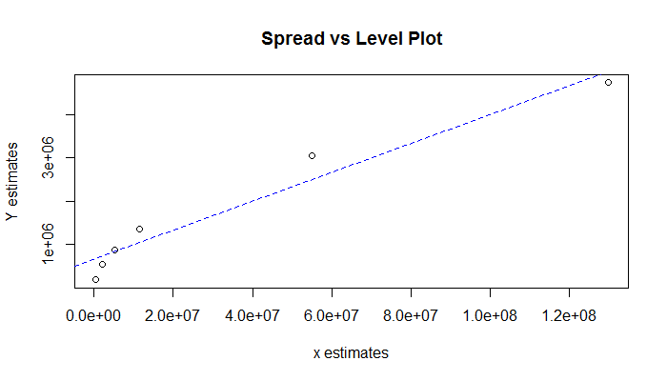

For the entire dataset, generating the p-estimate by considering it to be one single batch,

|  |  |  |  |  |  |  |  |
| --- | --- | --- | --- | --- | --- | --- | --- |
| Depth | XL | XU | Mid Summary | Spread | $$\frac{{(X_{L}-M)}^{2}+{(M-X_{U})}^{2}}{4M}$$ | $$\frac{XL+XU}{2}-M$$ | P estimate |
| 786.5 | 11104.5 | 66699 | 38901.75 | 55594.5 | 18232.06 | 13044.75 | 0.2845157 |
| 393.5 | 6157 | 157906.5 | 82031.75 | 151749.5 | 172343.66 | 56174.75 | 0.6740539 |
| 197 | 3423 | 321520 | 162471.5 | 318097 | 850058.92 | 136614.5 | 0.8392882 |
| 99 | 2071 | 622263 | 312167 | 620192 | 3444578.75 | 286310 | 0.916881 |
| 50 | 1321 | 919040 | 460180.5 | 917719 | 7719165.86 | 434323.5 | 0.9437344 |
| 25.5 | 813 | 1401948 | 701380.5 | 1401135 | 18314708.22 | 675523.5 | 0.9631158 |
| 13 | 662 | 1951269 | 975965.5 | 1950607 | 35849539.37 | 950108.5 | 0.9734973 |
| 7 | 494 | 2504700 | 1252597 | 2504206 | 59416269.29 | 1226740 | 0.9793535 |
| 4 | 416 | 3817117 | 1908766.5 | 3816701 | 138978803 | 1882909.5 | 0.9864518 |
| 2.5 | 188 | 4643567 | 2321877.5 | 4643379 | 206171486.9 | 2296020.5 | 0.9888635 |
| 1.5 | 86 | 7506640 | 3753363 | 7506554 | 541079576.5 | 3727506 | 0.993111 |
| 1 | 82 | 9818605 | 4909343.5 | 9818523 | 927201316.3 | 4883486.5 | 0.9947331 |

From the above table median p estimate is 0.9683065.

f) Find a and b of the matched transform:

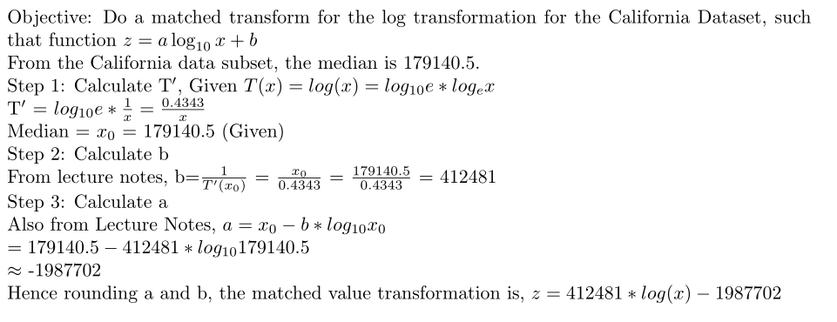

1. CEO Compensation Dataset
2. There are 1835 rows in the dataset. The highest CEO is paid 84515000. The unusual things is that dataset is that,
   1. 8 CEOs draw zero salary
   2. The data is dense in the sorted lower value segments and sparse in the higher end.

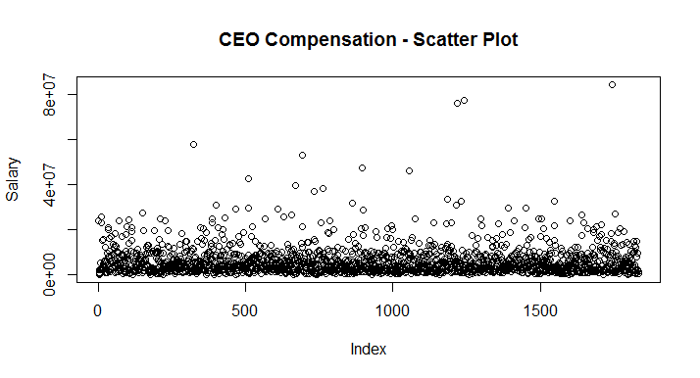

1. Following is the sorted salaries plotted by position, it can be seen that the linear is linear for lower and middle salaries, however it turns exponential!

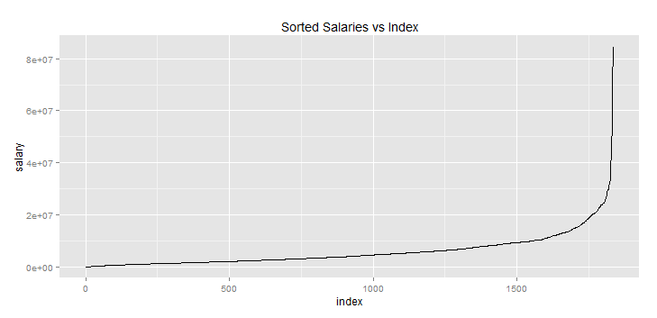

With respect to distribution, the distribution is skewed right as shown below.

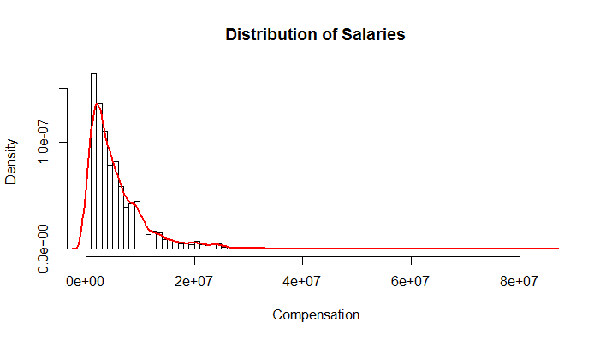

Following with our discussion the data symmetry, following is the box spot

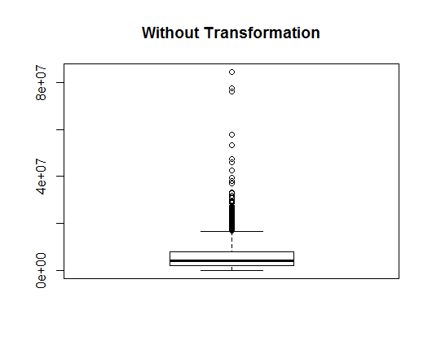

It can be seen that outliers present in the data distort the data representation.

1. Following is the transform for symmetry table

|  |  |  |  |  |  |  |  |
| --- | --- | --- | --- | --- | --- | --- | --- |
| Depth | XL | XU | Mid Summary | Spread | $$\frac{{(X_{L}-M)}^{2}+{(M-X_{U})}^{2}}{4M}$$ | $$\frac{XL+XU}{2}-M$$ | P estimate |
| F | 1987500 | 7857000 | 4922250 | 5869500 | 1177155 | 911250 | 0.2258876 |
| E | 1219000 | 11190000 | 6204500 | 9971000 | 3698162 | 2193500 | 0.4068675 |
| D | 754500 | 16102500 | 8428500 | 15348000 | 9773695 | 4417500 | 0.5480215 |
| C | 459000 | 21370000 | 10914500 | 20911000 | 19568162 | 6903500 | 0.6472075 |
| B | 279500 | 25320500 | 12800000 | 25041000 | 29170960 | 8789000 | 0.6987072 |
| A | 86000 | 31719000 | 15902500 | 31633000 | 48811948 | 11891500 | 0.7563814 |
| Z | 0 | 42589000 | 21294500 | 42589000 | 93764037 | 17283500 | 0.8156703 |
| Y | 0 | 55502500 | 27751250 | 55502500 | 166259206 | 23740250 | 0.8572094 |
| X | 0 | 76831500 | 38415750 | 76831500 | 331520403 | 34404750 | 0.8962213 |
| W | 0 | 81035500 | 40517750 | 81035500 | 370784201 | 36506750 | 0.9015418 |
| V | 0 | 84515000 | 42257500 | 84515000 | 404947777 | 38246500 | 0.905552 |

The median of the estimated p values is 0.75, hence plot square root transformation

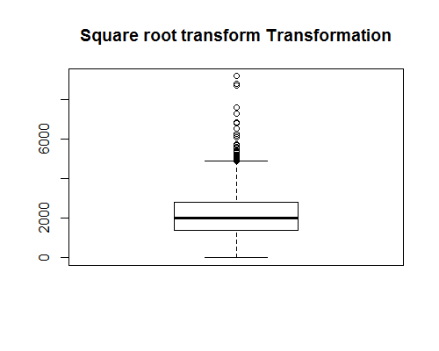

The Symmetry plot is,

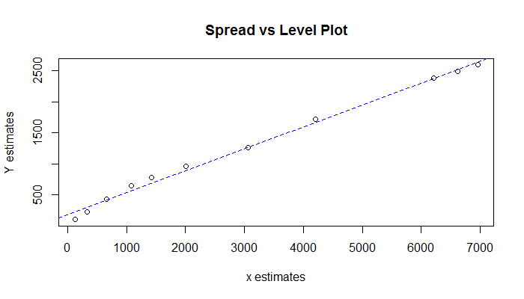

Consider another transform, fourth root transform, the box plot and symmetry plot is as follows,

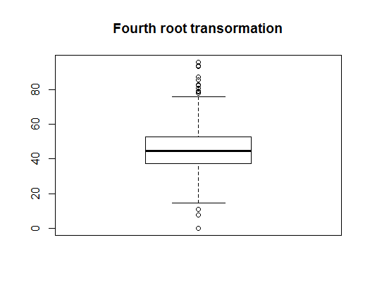

The symmetry plot is as follows,

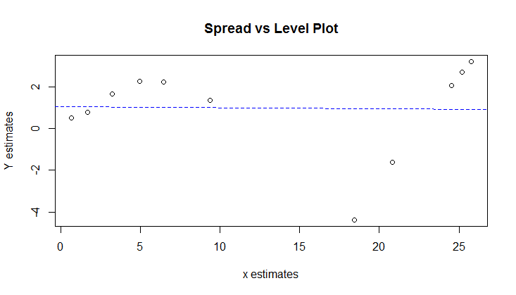

As seen from the above plot, since fourth root creates a straight line slope, as per the discussion in class, is more a proper transformation than the square root transform.

1. Since we cannot delete a data point, we cannot remove irregular values. However as shown above a proper transformation plot hugely increases the readability of the plot.
2. The two transformations are square root transformation and the fourth root transformation are already discussed in section 2.c
3. If one has to choose between the above two, a more apt one would be the fourth root. This can verified by plotting the transform plot for the fourth root of the dataset. We get a straight line, implying the transformation is correct.

|  |  |  |  |  |  |  |  |  |
| --- | --- | --- | --- | --- | --- | --- | --- | --- |
|  | Depth | Lower | Upper | Mid | Spread | xaxis | yaxis | pestimate |
| F | 459.5 | 37.5471 | 52.9437 | 45.2454 | 15.3965 | 0.6648534 | 0.4933 | 0.2580319 |
| E | 230 | 33.2277 | 57.8372 | 45.5325 | 24.6095 | 1.6984211 | 0.78035 | 0.5405439 |
| D | 115.5 | 29.4723 | 63.3465 | 46.4094 | 33.8741 | 3.2357364 | 1.6573 | 0.4878137 |
| C | 58 | 26.0287 | 67.991 | 47.0098 | 41.9622 | 4.9752536 | 2.25775 | 0.546204 |
| B | 29.5 | 22.9927 | 70.9356 | 46.9641 | 47.943 | 6.47482 | 2.21205 | 0.6583612 |
| A | 15 | 17.1248 | 75.0464 | 46.0856 | 57.9216 | 9.3906896 | 1.3335 | 0.8579976 |
| Z | 8 | 0 | 80.7838 | 40.3919 | 80.7838 | 18.440665 | -4.3602 | 1.2364448 |
| Y | 4.5 | 0 | 86.3004 | 43.1502 | 86.3004 | 20.83149 | -1.6019 | 1.076898 |
| X | 2.5 | 0 | 93.6227 | 46.8114 | 93.6227 | 24.530056 | 2.05925 | 0.916052 |
| W | 1.5 | 0 | 94.8623 | 47.4312 | 94.8623 | 25.215479 | 2.67905 | 0.8937538 |
| V | 1 | 0 | 95.8812 | 47.9406 | 95.8812 | 25.791724 | 3.1885 | 0.8763751 |
|  |  |  |  |  |  |  |  |  |
|  | **Depth** | **Lower** | **Upper** | **Mid** | **Spread** | **xaxis** | **yaxis** | **pestimate** |
| F | 459.5 | 1409.7872 | 2803.033 | 2106.41 | 1393.246 | 123.8372 | 103.6621 | 0.162916 |
| E | 230 | 1104.0833 | 3345.146 | 2224.615 | 2241.062 | 325.7561 | 221.8664 | 0.3189187 |
| D | 115.5 | 868.6192 | 4012.782 | 2440.7 | 3144.163 | 664.8969 | 437.9524 | 0.3413228 |
| C | 58 | 677.4954 | 4622.77 | 2650.133 | 3945.274 | 1076.1223 | 647.3844 | 0.39841 |
| B | 29.5 | 528.6672 | 5031.89 | 2780.278 | 4503.222 | 1416.6302 | 777.5304 | 0.4511409 |
| A | 15 | 293.2576 | 5631.962 | 2962.61 | 5338.705 | 2008.9339 | 959.8619 | 0.5222033 |
| Z | 8 | 0 | 6526.025 | 3263.012 | 6526.025 | 3054.6817 | 1260.2643 | 0.5874319 |
| Y | 4.5 | 0 | 7448.501 | 3724.25 | 7448.501 | 4202.6279 | 1721.5022 | 0.5903748 |
| X | 2.5 | 0 | 8765.261 | 4382.63 | 8765.261 | 6209.2899 | 2379.8822 | 0.6167223 |
| W | 1.5 | 0 | 8999.896 | 4499.948 | 8999.896 | 6612.2996 | 2497.2 | 0.6223402 |
| V | 1 | 0 | 9193.204 | 4596.602 | 9193.204 | 6954.651 | 2593.8539 | 0.6270332 |

From the above LV plots, it can be seen that mid summaries of the first LV plot is more stable than the mid summaries of the second LV plot

